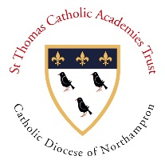
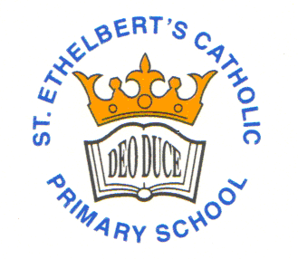
St. Ethelbert’s Catholic Primary School and Nursery
“Learning, achieving and growing together with Jesus”
Diocese of Northampton
Wexham Road, Slough, Berkshire SL2 5QR Telephone: 01753 522048 post@stethelberts.slough.sch.uk
Head of School: Mrs J. Rodrigues
Executive Headteacher: Mrs F. Maynard

INTIAL APPLICATION FORM FOR RECEPTION TO YEAR 6
Please note for a Reception place you must also register your child with the local authority. Failure to do so will risk your child’s school place in Reception.

Details of Student:
Legal first name: | Legal Surname: |  |  | Middle name:
Preferred Surname:  (if different from above) | Preferred First Name:  (if different from above)
Date of Birth: | Gender: Male / Female
Religion:
Address and Contact Details:
Address: |  |  | Postcode:
Mum’s Mobile Number: |  | Dad’s Mobile number:
Email Address:
E-mail:
Parent/(s) with parental responsibility:

Siblings (brothers/sisters) already at St. Ethelbert’s School:
Name of Sibling | Class and Year Group

Previous Schools:

Recent Arrivals:
1. Date of Arrival in the U.K.: | Nationality:

Languages spoken:
First Language: | Is English an additional Language for your child:  Yes / No

You must also provide copies of your child’s birth certificate, baptism certificate and a letter with your name and home address along with this application.

For office use only
Date application received:
Birth certificate seen and copied::
Evidence of religion seen and copied:
Proof of Address seen and copied:

