ST ETHELBERT’S CATHOLIC
PRIMARY SCHOOL AND NURSERY

Mental Health and Wellbeing Policy

Date of Review: July 2022
Date of Next Review: July 2023

1. Why mental health and wellbeing is important

At St Ethelbert’s school, we aim to promote positive mental health and wellbeing for our whole school community (children, staff, parents and carers), and recognise how important mental health and emotional wellbeing is to our lives in just the same way as physical health. We recognise that children’s mental health is a crucial factor in their overall wellbeing and can affect their learning and achievement.

The Department for Education (DfE) recognises that: “in order to help their children succeed; schools have a role to play in supporting them to be resilient and mentally healthy”.
Schools can be a place for children and young people to experience a nurturing and supportive environment that has the potential to develop self-esteem and give positive experiences for overcoming adversity and building resilience.

Our role at St Ethelbert’s is to ensure that children are able to manage times of change and stress, and that they are supported to reach their potential or access help when they need it. We also have a role to ensure that children learn about what they can do to maintain positive mental health, what affects their mental health, how they can help reduce the stigma surrounding mental health issues, and where they can go if they need help and support.

Our aim is to help develop the protective factors which build resilience to mental health problems and to be a school where:
- All children are valued.
- Children have a sense of belonging and feel safe.
- Children feel able to talk openly with trusted adults about their problems without feeling any stigma.
- Positive mental health is promoted and valued.
- Bullying is not tolerated.

In addition to children’s wellbeing, we recognise the importance of promoting staff mental health and wellbeing.

2. Definition of mental health and wellbeing

We use the World Health Organisation’s definition of mental health and wellbeing
“a state of well-being in which every individual realises his or her own potential, can cope with the normal stresses of life, can work productively and fruitfully, and is able to make a contribution to her or his community”.

Mental health and wellbeing is not just the absence of mental health problems. We want all children/young people to:
- feel confident in themselves.
- be able to express a range of emotions appropriately.
- be able to make and maintain positive relationships with others.
- cope with the stresses of everyday life.
- manage times of stress and be able to deal with change.
- learn and achieve.

3. A whole school approach to promoting positive mental health

We take a whole school approach to promoting positive mental health that aims to help children become more resilient, happy and successful and to prevent problems before they arise.

This encompasses seven aspects:
- Creating an ethos, policies and behaviours that support mental health and resilience, and which everyone understands.
- Helping children to develop social relationships, support each other and seek help when they need it.
- Helping children to be resilient learners.
- Teaching children social and emotional skills and an awareness of mental health.
- Early identification of children who have mental health needs and planning support to meet their needs, including working with specialist services.
- Effectively working with parents and carers.
- Supporting and training staff to develop their skills and their own resilience.

We also recognise the role that stigma can play in preventing understanding and awareness of mental health issues. We therefore aim to create an open and positive culture that encourages discussion and understanding of these issues.

4. Staff roles and responsibilities, including those with specific responsibility

We believe that all staff have a responsibility to promote positive mental health, and to understand about protective and risk factors for mental health. Some children will require additional help and all staff should have the skills to look out for any early warning signs of mental health problems and ensure that children with mental health needs get early intervention and the support they need.

All staff understand about possible risk factors that might make some children more likely to experience problems, such as: physical long-term illness, having a parent who has a mental health problem, death and loss, including loss of friendships, family breakdown and bullying. They should also understand the factors that protect children from adversity, such as self-esteem, communication and problem-solving skills, a sense of worth and belonging and emotional literacy.

Our Inclusion Lead for Social, Emotional & Mental Health Needs
- Leads and works with other staff to coordinate whole school activities to promote positive mental health and wellbeing.
- Leads on PSHCE teaching about mental health.
- Provides advice and support to staff and organises training and updates.
- Is the first point of contact with mental health services, and makes individual referrals to them.

We recognise that many behaviours and emotional problems can be supported within the School environment, or with advice from external professionals. Some children will need more intensive support at times, and there are a range of mental health professionals and organisations that provide support to children with mental health needs and their families.

Sources of relevant support include:
- Jessica Angliss – SENCo & Senior Mental Health Lead
- Jo Rodrigues – Deputy Head & Safe guarding Lead
- Kerry Slattery – Pupils wellbeing and safeguarding officer
- Maggie Brennan – Welfare & family support officer
- Aga Dyl-Wlk & Maria Anderton – ELSA
- MHST (Mental Health Support Team)
- Art Therapist – Annie Dashwood
- Drawing & Talking Therapy – Bernadette Sheehy
- CAMHs (children’s mental health service)
- Educational Psychologist
- SEBDOs (Social, Emotional & Behavioural outreach support)

More information and contact details of listed services can be provided upon request

7. | Supporting children’ positive mental heath

We believe the School has a key role in promoting children positive mental health and helping to prevent mental health problems. Our School has developed a range of strategies and approaches including:

Pupil-led activities
- Peer mediation and Peer mentoring
- Peer Mentors - a lunchtime group supporting younger children at lunchtime. Also includes children working together to solve problems and planned sessions where identified adults mentor a designated child

Class activities
- Circle times
- Work with KOOTH for Years 5 and 6 to support transition
- Mindfulness as part of daily time table

Whole school
- Enrichment weeks - whole school focus on doing things which make us feel good
- Wellbeing built into staff CPD
- Wellbeing Assemblies
- Displays and information around the School about positive mental health and where to go for help and support
- Staff mental health information readily available

Small group activities
- Nurture groups
- ELSA
- Art Therapy
- Lego Therapy
- SEBDOs

Through PSHCE we teach the knowledge and social and emotional skills that will help children to be more resilient, understand about mental health and be less affected by the stigma of mental health problems.

EYFS & Key Stage 1 children learn:
- To recognise, name and describe feelings including good and not so good feelings.
- Simple strategies for managing feelings.
- How their behaviour affects other people.
- About empathy and understanding other people’s feelings.
- To cooperate and problem solve.
- To motivate themselves and persevere.
- How to calm down.
- About change and loss and the associated feelings (including moving home, losing toys, pets or friends).
- Who to go to if they are worried.
- About different types of teasing and bullying, that these are wrong and unacceptable.
- How to resist teasing or bullying, if they experience or witness it, whom to go to and how to get help.

Key Stage 2 children learn:
- What positively and negatively affects their mental and emotional health (including the media).
- Positive and healthy coping strategies.
- About good and not so good feelings.
- To describe the range and intensity of their feelings to others.
- To recognise and respond appropriately to a wide range of feelings in others.
- To recognise that they may experience conflicting emotions and when they might need to listen to their emotions or overcome them.
- About resilience.
- How to motivate themselves and bounce back if they fail at something.
- How to empathise and be supportive of others.
- About change, including transitions (between Key Stages and schools), loss, separation, divorce and bereavement.
- About the consequences of discrimination, teasing, bullying and aggressive behaviours (including online bullying, prejudice-based language), as well as how to respond and ask for help if they are victims of this themselves.
- About the importance of talking to someone and how to get help.

8. Identifying, referring and supporting children with mental health needs

In the first instance, please always contact Jessica Angliss.
Our approach:
- Provide a safe environment to enable children to express themselves and be listened to.
- Ensure the welfare and safety of children are paramount.
- Identify appropriate support for children based on their needs.
- Involve parents and carers when their child needs support. •
- Involve children in the care and support they have.
- Monitor, review and evaluate the support with children and keep parents and carers updated.

Early Identification
Our identification system involves a range of processes. We aim to identify children with mental health needs as early as possible to prevent things getting worse. We do this in different ways including:
- SDQ (Social Difficulty Questionnaires).
- Termly student surveys.
- Analysing behaviour, exclusions, visits to the medical room/school nurse, attendance and sanctions reported from CPOMS.
- Staff report concerns about individual children to the relevant lead persons.
- Pupil Progress Review meetings termly.
- Gathering information from a previous school at transfer.
- Enabling children to raise concerns to any member of staff.
- Enabling parents and carers to raise concerns to any member of staff.

All staff at St Ethelbert’s have had training on the protective and risk, types of mental health needs and signs that might mean a pupil is experiencing mental health problems from the MHST. Any member of staff concerned about a pupil will take this seriously and talk to the Senior Mental Health Lead & SENCO.

These signs might include:
- Isolation from friends and family and becoming socially withdrawn.
- Changes in activity or mood or eating/sleeping habits.
- Falling academic achievement.
- Talking or joking about self-harm or suicide.
- Expressing feelings of failure, uselessness or loss of hope.
- Secretive behaviour.
- An increase in lateness or absenteeism.
- Not wanting to do PE or get changed for PE.
- Wearing long sleeves in hot weather.
- Physical signs of harm that are repeated or appear non-accidental.
- Repeated physical pain or nausea with no evident cause.

Staff are aware that mental health needs, such as anxiety, might appear as non-compliant, disruptive or aggressive behaviour which could include problems with attention or hyperactivity. This may be related to home problems, difficulties with learning, peer relationships or development.

If there is a concern that a pupil is in danger of immediate harm, then the School’s child protection procedures are followed. If there is a medical emergency, then the School’s procedures for medical emergencies are followed.

Disclosures by children and confidentiality

We recognise how important it is that staff are calm, supportive and non-judgemental to children who disclose a concern about themselves or a friend. The emotional and physical safety of our children is paramount and staff listen rather than advise. Staff make it clear to children that the concern will be shared with the Mental Health Lead or the Safeguarding Lead and recorded, in order to provide appropriate support to the pupil.

Assessment, Interventions and Support
In the first instance, please always contact Jessica Angliss.
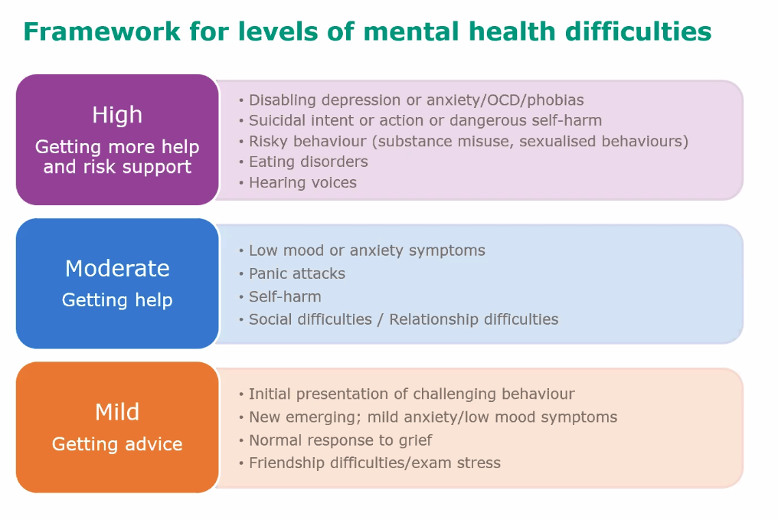
All concerns are reported to the Mental Health Lead and recorded. We then ensure that children get the support they need, either from within the School or from an external specialist service. Our aim is to put in place interventions as early as possible to prevent problems escalating.

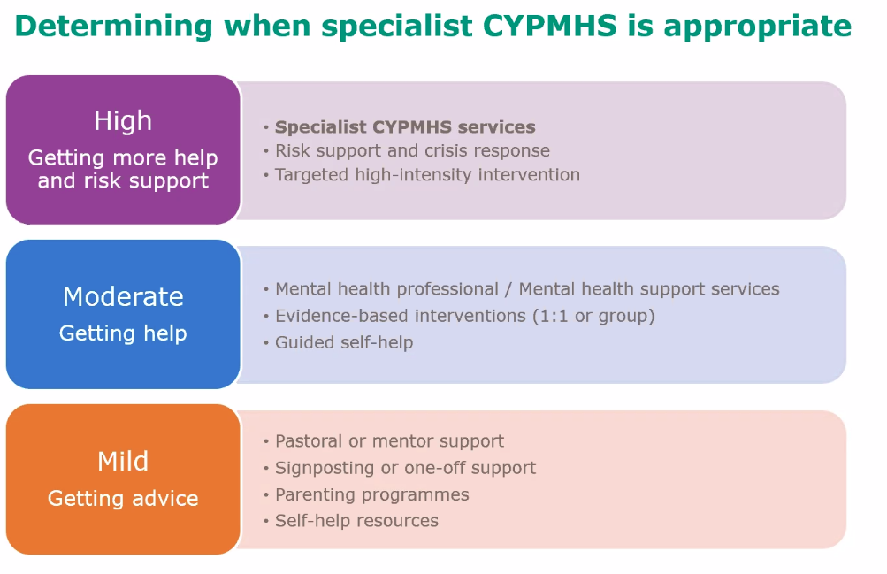

9. Working with specialist services to get swift access to the right specialist support and treatment

In some case a pupil’s mental health needs require support from a specialist service. These might include anxiety, depression, self-harm and eating disorders.

We have access to a range of specialist services and during the support will have regular contact with the service to review the support and consider next steps, as part of monitoring the children’ Individual Care Plan.

School referrals to a specialist service will be made by the Mental Health Lead and SENCO following the assessment process and in consultation with the pupil and his/her parents and carers. Referrals will only go ahead with the consent of the pupil and parent/carer and when it is the most appropriate support for the pupil’s specific needs.

Main Specialist Service | Referral process
Child and Adolescent Mental Health Service (CAMHS) | Accessed through school, GP or self-referral
Educational Psychologist | Accessed through the Mental Health Lead or  SENCO

SEND and mental health

Persistent mental health problems may lead to children having significantly greater difficulty in learning than the majority of those of the same age. In some cases, the child may benefit from being identified as having a special educational need (SEN).

10. Involving parents and carers

Promoting mental health
We recognise the important role parents and carers have in promoting and supporting the mental health and wellbeing of their children, and in particular supporting children who do have mental health needs.

We ask parents to inform us of any mental health needs their child has and any issues that they think might have an impact on their child’s mental health and wellbeing, based on a list of risk factors pertaining to the child or family. It is very helpful if parents and carers can share information with the School so that we can better support their child from the outset. All information will be treated in confidence.

Supporting parents and carers with children with mental health needs
We are aware that parents and carers react in different ways to knowing their child has a mental health problem and we will be sensitive and supportive. We also aim to reassure by explaining that mental health problems are common, that the school has experience of working with similar issues and that help and advice are available.

We make every effort to support parents and carers to access services where appropriate. Our primary concern is the children, and in the rare event that parents and carers are not accessing services we will seek advice from the Local Authority and Mental Health Support Team. We also provide information for parents and carers to access support for their own mental health needs.

11. Involving children

Every year we train up a group of children as our Peer Mentors who lead on whole school campaigns on health and wellbeing.

We seek pupil’s views about our approach, curriculum and in promoting whole school mental health activities.

12. Supporting and training staff

We want all staff to be confident in their knowledge of mental health and wellbeing and to be able to promote positive mental health and wellbeing, identify mental health needs early in children and know what to do and where to get help. Our Mental Health Lead and Safeguarding officer are qualified ‘mental health first aiders’.

Supporting and promoting the mental health and wellbeing of staff is an essential component of a healthy school and we promote opportunities to maintain a healthy work life balance and wellbeing. We have a wellbeing day once a year for staff as well as opportunities for wellbeing to be built into staff CPD and whole school planning.

Our Mental Health Support Team offer training for all staff.

13. Monitoring and Evaluation

The mental health and wellbeing policy is on the school website and hard copies are available to parents and carers from the school office. All mental health professionals are given a copy before they begin working with the school as well as external agencies involved in our mental health work.

The policy is monitored at an annual review meeting led by the Senior Mental Health Lead and involves staff with a responsibility for mental health, including specialist services supporting the school and governors.
This policy has been devised in consultation with all stakeholders of St Ethelbert’s Catholic Primary School.

Appendices

Appendix 1 Specific mental health needs most commonly seen in school-aged children

For information see Annex C Main Types of Mental Health Needs Mental Health and Behaviour in School DfE March 2016
https://www.gov.uk/government/publications/mental-health-and-behaviour-in-schools--2

Annex C includes definitions, signs and symptoms and suggested interventions for
- Anxiety (including panic attacks, phobias and Obsessive Compulsive Disorder OCD)
- Depression
- Eating Disorders
- Substance Misuse
- Self Harm

Appendix 2 Where to get information and support

For support on specific mental health needs
Anxiety UK www.anxietyuk.org.uk OCD UK www.ocduk.org
Depression Alliance www.depressoinalliance.org
Eating Disorders www.b-eat.co.uk and www.inourhands.com
National Self-Harm Network www.nshn.co.uk
www.selfharm.co.uk
Suicidal thoughts Prevention of young suicide UK – PAPYRUS: www.papyrus-uk.org

For general information and support
www.youngminds.org.uk champions young people’s mental health and wellbeing www.mind.org.uk advice and support on mental health problems www.minded.org.uk (e-learning)
www.time-to-change.org.uk tackles the stigma of mental health www.rethink.org challenges attitudes towards mental health

